**ITM 301 FINAL PROJECT**

**Data Base Management**

By

Rashid Nabha

Lara Nassif

Romanos Rizk

Submitted to the Adnan Kassar School of Business

In Partial Fulfillment of the Requirements for ITM 302 course

**2022**

©2022 by Rashid Nabha, Romanos Rizk, & Lara Nassif

Table of Contents:

1)Interview: 3

2)Scenario: 5

3) Business Rules: 6

4) Description Of Entities: 7

5) Relational Schema: 9

6) Enhanced ER-Diagram: 12

7) Schema Diagram: 13

8) Mapping: 14

9)Normalized Schema: 19

10)Table Creation: 21

11) SQL Management (Studio Tables): 24

12) SQL Management (Descriptions of Studio Tables): 28

13) SQL Management Sudio (Insert into Tables): 36

14) SQL Management Studio (Populated Tables): 39

15) SQL Management Studio (Queries): 45

16) Progress Report 46

1. ***Interview Report:***

|  |  |
| --- | --- |
| Date | 12/10/2022 at 6:00 pm |
| Participation | Wassim Abbass |
| Duration | 35 mins |

|  |  |  |
| --- | --- | --- |
| Time | Questions | Answers |
| 3 min | How many departments do you operate? | We mainly have five departments in our company that are IT, HR, Marketing, Accounting, and finance. |
| 3 min | What information do you keep about the departments that you have? | It is important for us to keep track of the number of employees that work in the department, the name of the department, and the department number. |
| 1 min | What types of employees do you hire? (Regular employee, manager…..) | The employees that we hire can be managers, supervisors, or regular employees depending on their skills and experience. |
| 4 min | Can an employee work in more than one department or a manager to manage more than one department? | No, an employee can work in only one department. In addition, every department should be managed by only one manager and the reason is for enhancing the efficiency and the productivity of the employees. |
| 1 min | How can employees finish their tasks? | Every regular employee should join a team that is responsible for many tasks. |
| 2 min | What information do you keep about the tasks and the teams? | We keep the number of employees that are working in the team and the team number. As for the tasks, we store the task number and the date of the task completed. |
| 2 min | How are the teams and tasks organized? | All the teams are supervised by a supervisor to get their tasks completed. |
| 3 min | What information do you store about your employees? | We keep personnel information about our employees such as the EmployeeID, First Name, Last Name, Phone number, Address, and the department number that they work in. |
| 3 min | How does the information that you store about the managers and supervisors differ? | The information that we keep about the managers is the number of years they have spent in the department that they manage and the salary. However, for the supervisor we want to know the number of employees they are supervising and their salary. |
| 2 min | What information do you store about your customers? | We keep their Customer ID, first name, last name, phone number, address. |

|  |  |  |
| --- | --- | --- |
| 4 min | What are the services that you offer? | We offer 5 different types of services that are Telematics solutions for sensors and tracking devices, IT solutions, Software Solutions, Power Backup and Microsoft business solutions. |
| 2 min | What information do you keep about the services that you offer? | The main information that we need for services is the number of the service, name of the service, cost and type. |
| 2 min | How do you organize the services? | All the services offered by our company are organized by the Network Operations Center (NOC) team. |

1. ***Scenario:***

One of the top ISPs in Lebanon, Pros Services reaches out to host all content providers at their data center and is a turnkey provider of high-quality internet services including IPTV, smart homes, and IOT solutions. Pros Services, an ISP with a license from the Ministry of Telecommunications since 2008, has prospered over the course of 14 years in business, building a reputation for high-quality work, and intends to keep improving its standing in the sector. Pros Services quickly expanded to become one of the top businesses in Lebanon supplying the market with the ideal ingredient combination of IT and business solutions thanks to a group of extremely skilled managers and staff.

The company operates through 500+ links it has installed all over Lebanon focusing on 5 main zones Beirut, South Lebanon, Beqaa’, North Lebanon, and Mount Lebanon. Pros-Services operates the most robust and powerful platforms. Their services include but are not limited to solutions for power backup, telematics (tracking devices, sensors), software, hardware (Cisco servers), and Microsoft business solutions. The services come complete with a bandwidth management system that provides detailed usage reports and allows managing the client service better than anyone in the field can.

Therefore, if a client experiences technical difficulties, the business would be liable for resolving the issue and giving the client the remedy immediately. The personnel would be operating and working in teams to perform their jobs since all departments inside the corporation operate the services as a whole sector. Each department has a manager, and each team has a supervisor.

Additionally, due to the ongoing progress of technology in this digital era, it is essential for the business to have all its internal systems updated and upgraded to stay abreast of new developments. Due to the company's use of such sophisticated technologies, business-to-business and individual consumer interactions account for most of its transactions, which benefits it by allowing it to interact with its primary target market. Customers call the business after closing a contract searching for answers in a certain area. The firm then performs an interview with them to discuss the issue and perform the necessary analysis before giving the client the required solution. And based on the circumstances, the business would make the client an offer that contained the right and optimal remedies. Finally, a firm employee physically contacts the customer, installs the required software, and instructs and mentors the client on how to use the product.

1. ***Business Rules:***

1)An employee must work in one department.

2)A department must contain many employees.

3)A department must operate many services.

4)A service must be operated by many departments.

5)A service may be an IT solution.

6)A service may be a power backup solution.

7)A service may be a telematics solution.

8)A service may be a software solution.

9)A service may be a Microsoft business solution.

10)A service may be sold to many customers.

11)A customer may purchase many services.

12)An employee may be a regular employee.

13)An employee may be a manager.

14)An employee may be a supervisor.

15)A manager must manage one department.

16)A department must be managed by one manager.

17)A regular employee must work in one team.

18)A team must contain many regular employees.

19)A team must have a supervisor.

20)A supervisor must supervise one team.

21)A task must be completed by one team.

22)A team may complete many tasks.

1. ***Description Of Entities:***

* Services: The components of a service are its name, its cost, its category, and its special service number (identifier). The offered service kinds are represented by the subtypes of the services entity, which is a super-type.
* Department: Departments consist of a department name, a special department number (identifier), and the number of personnel. These divisions include the departments of IT, HR, accounting, marketing, and finance. And a manager oversees each department.
* Employee: An employee is a person who works for a certain department and is identified by their unique employer identity, first and last names, addresses, phone numbers, and employee type. Employee entity is a supertype, and employee kinds are represented by its subtypes.
* IT Solutions: Every IT solution is provided to address a specific IT issue. (Subtype of services)
* Power Backup: Each Backup power solution has a set amount of time that it may be used. (Subtype of services)
* Software Solution: Every software option comes with unique software advantages. (Subtype of services)
* Telematics Solution: Every Telematics solution is practical for a device, according to the term. (Subtype of services)
* Microsoft Business: A description is provided for each license. (Subtype of services)
* Manager: Each manager lists their pay and the number of years they have worked in the department. Each manager also oversees a certain department. (Subtype of employee)
* Supervisor: Each supervisor oversees several employees and gets paid. And each manager oversees one squad. (Subtype of employee)
* Regular employee: Regular employees are paid a wage and are a part of a team. (Subtype of employee)
* Team: Each has a distinct team number and a certain number of personnel. Each Team is assigned tasks.
* Task: Each task is identified by a primary key (task number) and includes the date it was finished
* Customer: Consists of the customer's first and last name, address, and phone number in addition to a special customer identification.

1. ***Relational Schema:***

# May be:

Services

Software Solution

Microsoft Business

Power Backup

Telematics Solution

IT Solution

Since a service type can be a power backup solution, telematics solution, software solution, IT solution, or Microsoft Business, the services entity in this relationship acts as a super-type with sub-types that represent the many types of services.

# Operates:

Department

Services

Since a department is responsible for running every service the firm offers, and since every department in the organization is responsible for running every service, there are many to many links between departments and services.

# Purchase:

Services

Customer

Since a consumer may buy several services and multiple customers may be given a service, the connection between the customer and the service is one of many to many.

# Works for:

Employee

Department

There must be a "works for" link established between both the department entity as well as the employee entity for each department to have multiple workers. Every one of the entities is fully involved since each department needs personnel, and those individuals must all be employed by that department. Additionally, a department has many people working for it, and a worker may only work for one department at a time, therefore the connection is one to many.

# May be:

Employee

Supervisor

Manager

Regular Employee

An employee may be a normal employee, a manager, or a supervisor in this relationship. The employee entity is indeed a super-type with sub-types that reflect the various employee kinds in the business.

# Manages:

Department

Manager

There is a link between a manager (employee) and a department since a manager oversees a department. One manager oversees one department, which is under the direction of one manager. It is a one-to-one relationship as a result.

# Supervises:

**c**

Team

Supervisor

A team is overseen by a supervisor, hence there is a link between the team and the supervisor (employee). One supervisor oversees a single team, but one supervisor oversees one team. It is a one-to-one relationship as a result.

# Works for:

Regular Employee

Team

There must be a "works for" link established seen between team entity and regular employee subtype for each team to have several regular workers working for it. Because all teams require regular employees and because all regular employees must be employed by a certain Team, every one of the entities seems to have a 100% participation. A team also has several regular employees working for it, and as a regular employee may only work for one department, the connection is one to many.

# Completes:

Task

Team

Since each team must finish several tasks, a completes link in between team entity and the task entity must be established since each job must be completed by a different team. It is a one-to-many relationship as a result.

1. ***Enhanced ER-Diagram:***

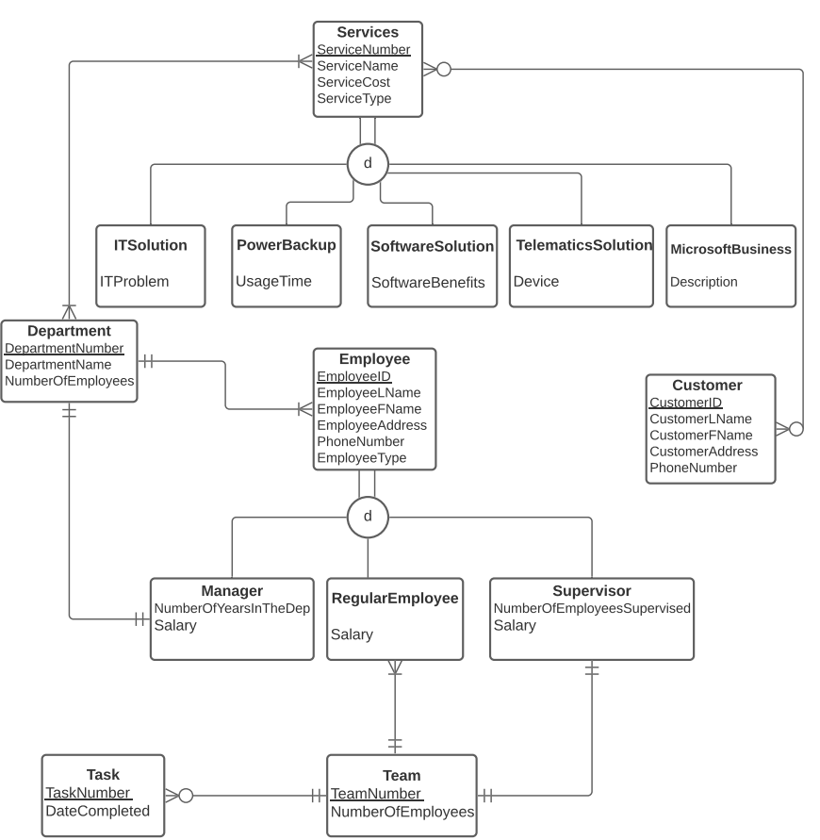

1. ***Schema Diagram:***

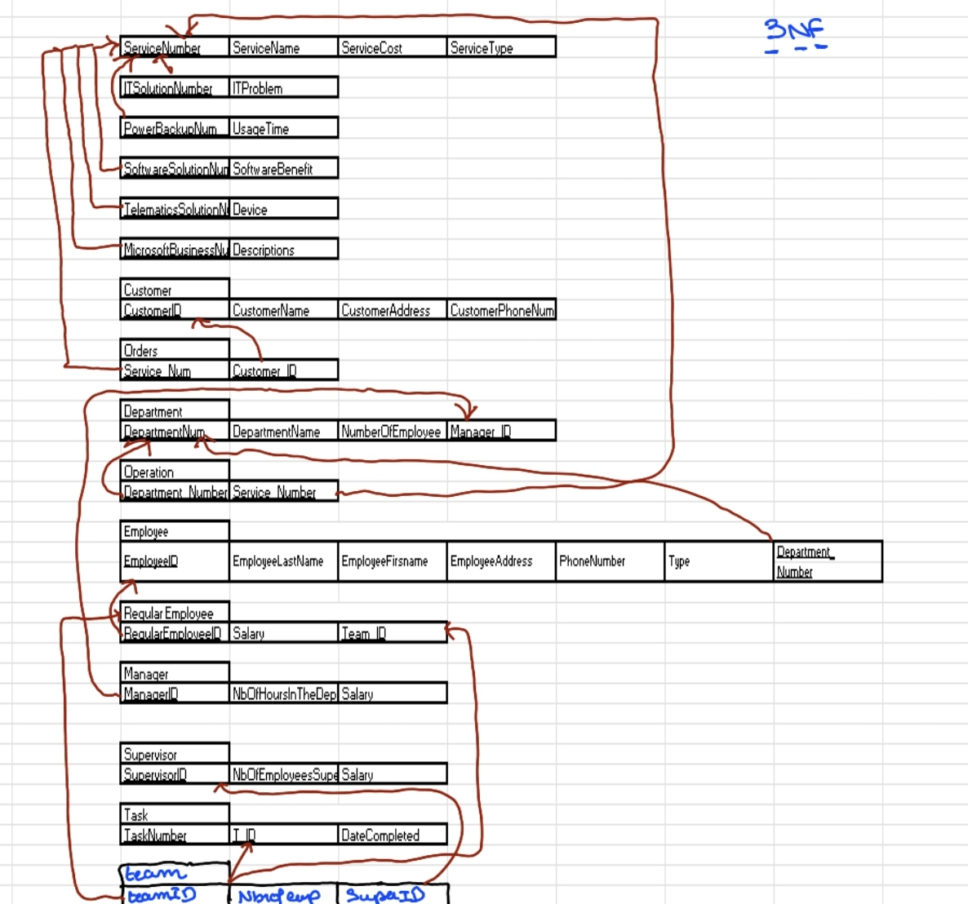

1. ***Mapping:***

# May be:

|  |  |  |  |
| --- | --- | --- | --- |
| ServiceNum | ServiceName | ServiceCost | ServiceType |

|  |  |
| --- | --- |
| ITSolutionNum | ITProblem |

|  |  |
| --- | --- |
| PowerBackupNum | UsageTime |

|  |  |
| --- | --- |
| SoftwareSolutionNum | SoftwareBenefit |

|  |  |
| --- | --- |
| TelematicsSolutionNum | Device |

|  |  |
| --- | --- |
| MicrosoftBusinessNum | Descriptions |

The supertype is the services entity, while the subtypes are Microsoft Business, Telematics Solution, Software Solution, Power Backup Solution, and IT Solution. Each subtype's main key additionally contains a foreign key that is referred to via the supertype services. Because of this, an arrow is shown connecting the primary key of each subtype to the key of the supertype.

# Purchase:

|  |  |  |  |
| --- | --- | --- | --- |
| Customer |  |  |  |
| CustomerID | CustomerName | CustomerAddress | CustomerPhoneNum |

|  |  |
| --- | --- |
| Orders |  |
| Service_Num | Customer_ID |

|  |  |  |  |
| --- | --- | --- | --- |
| ServiceNum | ServiceName | ServiceCost | ServiceType |

The customer entity and the services entity have a many-to-many relationship, thus a new relation named order is made with a composite primary key (both primary keys of services and customer). Because of this, an arrow is seen connecting each component of the composite primary key to the primary keys for the relations between services and consumers.

# Operate:

|  |  |  |  |
| --- | --- | --- | --- |
| ServiceNum | ServiceName | ServiceCost | ServiceType |

|  |  |
| --- | --- |
| Operation |  |
| Department_Number | Service_Number |

|  |  |  |
| --- | --- | --- |
| Department |  |  |
| DepartmentNum | DepartmentName | |  |  | | --- | --- | | NumberOfEmployees | Manager_ID | |

The department entity and the service entity have a many-to-many relationship; as a result, a new relation named operation is constructed with a composite key made up of both the department and service primary keys. Because of this, an arrow is shown leading from either end of the composite primary key towards the department and service relations primary key.

# Work in:

|  |  |  |  |  |
| --- | --- | --- | --- | --- |
| Department |  |  | |  |
| DepartmentNum | DepartmentName | NumberOfEmployees | Manager_ID |  |

|  |
| --- |
| Employee |
| EmployeeID | EmployeeLastName | EmployeeFirsname | EmployeeAddress | PhoneNumber | Type | Department_  Number |

The department entity and employee entity have a one-to-many connection. As a result, the primary key on one side is now a foreign key on the other. This explains why an arrow points from the department relation's primary key to the foreign key in the employee relation.

May be:

|  |
| --- |
| Employee |
| EmployeeID | EmployeeLastName | EmployeeFirstname | EmployeeAddress | PhoneNumber | Type | Department_  Number |

|  |
| --- |
| Regular Employee |
| RegularEmployeeID | Salary | Team_ID |

|  |  |  |
| --- | --- | --- |
| Manager |  |  |
| ManagerID | NbOfHoursInTheDepartment | Salary |

|  |  |  |
| --- | --- | --- |
| Supervisor |  |  |
| SupervisorID | NbOfEmployeesSupervised | Salary |

Regular Employee, Supervisor, and Manager are the subtypes under the super-type of the employee entity. Each subtype additionally has a main key that is a foreign key that is linked to the super-type of employee. Because of this, an arrow is seen connecting the primary key of each subtype to the key to the super-type.

# Manages:

|  |  |  |
| --- | --- | --- |
| Manager |  |  |
| ManagerID | NbOfHoursInTheDepartment | Salary |

|  |  |  |  |  |
| --- | --- | --- | --- | --- |
| Department |  |  | |  |
| DepartmentNum | DepartmentName | NumberOfEmployees | Manager_ID |  |

The manager entity and the department entity have a one-to-one connection. Since the relation is required on both sides, the main key on one side may turn into a foreign key on the other. Because of this, an arrow is seen from the department relation's foreign key to the manager relation's primary key.

# Work in:

|  |
| --- |
| Regular Employee |
| RegularEmployeeID | Salary | Team_ID |

|  |
| --- |
| Team |
| TeamID | NumberOfEmployees | SuperID |

The team entity and the Regular employee entity have a one-to-many connection. The primary key on one side changes to a foreign key on another. Therefore, the team entity's main key is converted to a foreign key in the standard employee entity. The arrow connecting the standard employee entity to the team entity may be seen as a result.

# Supervise:

|  |  |  |
| --- | --- | --- |
| Supervisor |  |  |
| SupervisorID | NbOfEmployeesSupervised | Salary |

|  |
| --- |
| Team |
| TeamID | NumberOfEmployees | SuperID |

The supervisor entity and the team entity have a one-to-one connection. Given that the relation is necessary on both sides, the primary key on one side may turn into a foreign key on the other. As a result, the team entity now uses the supervisor entity's primary key as a foreign key. Because of this, an arrow is shown from the team entity to the supervisor entity's primary key.

# Completes:

|  |
| --- |
| Team |
| TeamID | NumberOfEmployees | SuperID |

|  |
| --- |
| Task |
| TaskNumber | T_ID | DateCompleted |

The team entity and the task entity are connected in a one-to-many relationship. On one side, the primary key changes into a foreign key on the other. As a result, the task entity's foreign key for the team entity's primary key. The primary key of said team entity is shown by an arrow that leads from the task entity.

1. ***Normalized Schema:***

Services: **3rd Normal form**

|  |  |  |  |
| --- | --- | --- | --- |
| ServiceNum | ServiceName | ServiceCost | ServiceType |

IT Solution: **3rd Normal form**

|  |  |
| --- | --- |
| ITSolutionNum | ITProblem |

Power Backup: **3rd Normal form**

|  |  |
| --- | --- |
| PowerBackupNumber | UsageTime |

Software Solution: **3rd Normal form**

|  |  |
| --- | --- |
| SoftwareSolutionNum | SoftwareBenefit |

Telematics Solution: **3rd Normal form**

|  |  |
| --- | --- |
| TelematicsSolutionNum | Device |

Microsoft Business: **3rd Normal form**

|  |  |
| --- | --- |
| MicrosoftBusinessNum | Descriptions |

Customer: **3rd Normal form**

|  |  |  |  |
| --- | --- | --- | --- |
| CustomerID | CustomerName | CustomerAddress | CustomerPhoneNumber |

Order: **3rd Normal form**

|  |  |  |  |
| --- | --- | --- | --- |
| ServiceNum | ServiceName | ServiceCost | ServiceType |

Department: **3rd Normal form**

|  |  |  |  |
| --- | --- | --- | --- |
| DepartmentNum | DepartmentName | NumberOfEmployees | Manager_ID |

Operation: **3rd Normal form**

|  |  |
| --- | --- |
| Department_Number | Service_Number |

Employee: **3rd Normal form**

|  |  |  |  |  |  |
| --- | --- | --- | --- | --- | --- |
| EmployeeID | EmployeeLastName | EmployeeFirstName | EmployeeAddress | Department_Number | Type |

Regular Employee: **3rd Normal form**

|  |  |  |
| --- | --- | --- |
| RegularEmployeeID | Salary | Team_ID |

Supervisor: **3rd Normal form**

|  |  |  |
| --- | --- | --- |
| SupervisorID | NumberOfEmployeesSupervised | Salary |

Manager: **3rd Normal form**

|  |  |  |
| --- | --- | --- |
| ManagerID | NumberOfHoursInTheDepartment | Salary |

Team: **3rd Normal form**

|  |  |  |
| --- | --- | --- |
| TeamID | NumberOfEmployees | SuperID |

Task: **3rd Normal form**

|  |  |  |
| --- | --- | --- |
| TaskNumber | T_ID | DateCompleted |

All the relations are in the 3rd normal form since there are no multivalued attributes, no partial dependencies, and no transitive dependencies.

1. ***Table Creation:***

# Customer:

|  |  |  |  |  |  |
| --- | --- | --- | --- | --- | --- |
|  | CustomerID | CustomerLastName | CustomerFirstName | CustomerAddress | CustomerPhoneNumber |
| Data Type | Nchar | Varchar | Varchar | Varchar | Nchar |
| Length | 18 | 20 | 20 | 20 | 16 |
| Null | No | No | No | Yes | Yes |
| PK/FK | Primary Key | No | No | No | No |

# Department:

|  |  |  |  |  |
| --- | --- | --- | --- | --- |
|  | DepartmentNum | DepartmentName | NumberOfEmployees | Manager_ID |
| Data Type | Integer | Varchar | Integer | Nchar |
| Length | 4 | 20 | 4 | 18 |
| Null | No | No | No | Yes |
| PK/FK | PK | No | No | FK |

# Employee:

|  |  |  |  |  |  |  |  |
| --- | --- | --- | --- | --- | --- | --- | --- |
|  | EmployeeID | EmployeeLastName | EmployeeFirstName | EmployeeAddress | EmployeePhoneNum | Department_Number | Type |
| Data Type | Nchar | Varchar | Varchar | Varchar | Nchar | Integer | Varchar |
| Length | 18 | 20 | 20 | 50 | 22 | 4 | 20 |
| Null | No | No | No | Yes | Yes | Yes | Yes |
| PK/FK | Primary Key | No | No | No | No | Foreign Key | No |

# Manager:

|  |  |  |  |
| --- | --- | --- | --- |
|  | ManagerID | NumberOfHoursInDepartment | Salary |
| Data Type | Nchar | Integer | Integer |
| Length | 18 | 4 | 20 |
| Null | No | Yes | Yes |
| PK/FK | Primary Key | No | No |

# Regular Employee:

|  |  |  |  |
| --- | --- | --- | --- |
|  | RegularEmployeeID | Team_ID | Salary |
| Data Type | Nchar | Integer | Integer |
| Length | 18 | 4 | 20 |
| Null | No | No | Yes |
| PK/FK | Primary key | Foreign Key | No |

# Supervisor:

|  |  |  |  |
| --- | --- | --- | --- |
|  | SupervisorID | NumberOfEmployeesSupervised | Salary |
| Data Type | Nchar | Integer | Integer |
| Length | 18 | 4 | 20 |
| Null | No | yes | Yes |
| PK/FK | Primary Key/Foreign Key | No | No |

# Operation:

|  |  |  |
| --- | --- | --- |
|  | Department_Number | Service_Number |
| Data Type | Integer | Integer |
| Length | 4 | 4 |
| Null | No | No |
| PK/FK | Primary Key/Foreign Key | Primary Key/Foreign Key |

# Team:

|  |  |  |  |
| --- | --- | --- | --- |
|  | TeamID | SuperID | NumberOfEmployees |
| Data Type | Integer | Nchar | Integer |
| Length | 4 | 18 | 4 |
| Null | No | No | Yes |
| PK/FK | Primary Key | Foreign Key | No |

# Task:

|  |  |  |  |
| --- | --- | --- | --- |
|  | TaskNumber | T_ID | DateCompleted |
| Data Type | Integer | Integer | Varchar |
| Length | 4 | 4 | 20 |
| Null | No | No | Yes |
| PK/FK | Primary Key | Foreign Key | No |

# Service:

|  |  |  |  |  |
| --- | --- | --- | --- | --- |
|  | ServiceNum | ServiceName | ServiceCost | ServiceType |
| Data Type | integer | Varchar | Varchar | Varchar |
| Length | 4 | 20 | 20 | 20 |
| Null | No | No | Yes | Yes |
| PK/FK | Primary Key | No | No | No |

# IT Solution:

|  |  |  |
| --- | --- | --- |
|  | ITSolutionNum | ITProblem |
| Data Type | Integer | Varchar |
| Length | 4 | 20 |
| Null | No | Yes |
| PK/FK | Primary Key/Foreign Key | No |

# Microsoft Business:

|  |  |  |
| --- | --- | --- |
|  | MicrosoftBusinessNum | Descriptions |
| Data Type | Integer | Varchar |
| Length | 4 | 20 |
| Null | No | Yes |
| PK/FK | Primary Key/Foreign Key | No |

# Power Backup:

|  |  |  |
| --- | --- | --- |
|  | PowerBackupNum | UsageTime |
| Data Type | Integer | Float |
| Length | 4 | 20 |
| Null | No | Yes |
| PK/FK | Primary Key/Foreign Key | No |

# Software Solution:

|  |  |  |
| --- | --- | --- |
|  | SoftwareSolutionNum | SoftwareBenefit |
| Data Type | Integer | Varchar |
| Length | 4 | 20 |
| Null | No | Yes |
| PK/FK | Primary Key/ Foreign Key | No |

# Telematics Solutions:

|  |  |  |
| --- | --- | --- |
|  | TelematicsSolutionNum | Device |
| Data Type | Integer | Varchar |
| Length | 4 | 20 |
| Null | No | Yes |
| PK/FK | Primary Key/Foreign Key | No |

# Order:

|  |  |  |
| --- | --- | --- |
|  | Service_Num | Customer_ID |
| Data Type | Integer | Nchar |
| Length | 4 | 18 |
| Null | No | No |
| PK/FK | Primary Key | Primary Key/Foreign Key |

1. **SQL Management Studio Tables:**

# Table Creation:

# 1-Table concerning Employees:

Create Table Employee (

EmployeeID NCHAR (9) NOT null,

EmployeeLastName varchar (20) not null,

EmployeeFirstName varchar (20) not null,

EmployeeAddress varchar (50),

EmployeePhoneNum nchar (11),

Department_Number integer,

EmployeeType varchar (20),

Primary key (EmployeeID),

Foreign key ( Department_Number) references Department);

Create table Supervisor (

SupervisorID nchar (9) not null,

NumberOfEmployeeSupervised integer ,

Salary Integer,

Primary key (SupervisorID),

Foreign key (SupervisorID) references employee);

Create Table RegularEmployee (

RegularEmployeeID nchar (9) not null,

Team_ID integer not null,

Salary integer,

Primary Key (RegularEmployeeID),

Foreign key (RegularEmployeeID) references employee ,

Foreign key (Team_ID) references Team);

Create Table Manager (

ManagerID nchar (9) not null,

NumberOfHoursInDepartment integer,

Salary integer,

Primary key (ManagerID),

Foreign key (ManagerID) references employee);

Create Table Team (

TeamID integer not null,

SuperID nchar (9) not null,

NumberOfEmployees integer,

Primary key (TeamID),

Foreign key ( SuperID) references supervisor );

Create table Department (

DepartmentNum integer not null,

DepartmentName varchar (20) not null,

NumberOfEmployees integer not null,

Primary key (DepartmentNum));

Create Table Task (

TaskNumber integer not null,

T_ID integer not null,

DateCompleted varchar (20),

Primary key ( TaskNumber),

Foreign key ( T_ID) references Team);

Create table Operation (

Department_Number integer not null,

Service_Number integer not null,

Primary key ( Department_Number, Service_Number),

Foreign key ( Department_Number) references department,

Foreign key (Service_Number) references Service);

# 2-Tables concerning Customers:

Create table Customer (

CustomerID nchar (9) not null,

CustomerLastName varchar (20) not null,

CustomerFirstName varchar (20) not null,

CustomerAddress varchar (20) ,

CustomerPhoneNum nchar (8) ,

Primary key (CustomerID));

Create table Orders (

Service_Num integer not null,

Customer_ID nchar (9) not null,

Primary key (Service_Num, Customer_ID),

Foreign key (Customer_ID) references Customer,

Foreign key (Service_Num) references service);

# 3-Tables concerning Services:

Create table service(

ServiceNum integer not null,

ServiceName varchar(20) not null,

ServiceCost integer,

ServiceType varchar (20),

Primary key(ServiceNum));

Create table TelematicsSolution (

TelematicsSolutionNum integer not null,

Device varchar (20),

Primary key (TelematicsSolutionNum),

Foreign key (TelematicsSolutionNum) references service);

Create table ITSolution(

ITSolutionNum integer not null,

ITProblem varchar (20),

Primary key (ITSolutionNum),

Foreign key (ITSolutionNum) references service);

Create table PowerBackup (

PowerBackupNum integer not null,

UsageTime float,

Primary key(PowerBackupNum),

Foreign key (PowerBackupNum) references service);

Create table SoftwareSolution (

SoftwareSolutionNum integer not null,

SoftwareBenefit varchar (20),

Primary key (SoftwareSolutionNum),

Foreign key(SoftwareSolutionNum) references service);

Create table MicrosoftBusiness (

MicrosoftBusinessNum integer not null,

Descriptions varchar (20),

Primary key (MicrosoftBusinessNum),

Foreign key (MicrosoftBusinessNum) references service);

**Note: table creation order in SQL differs since tables that carry dependencies should be created first.**

1. ***SQL Management Studio Table Description:***

# 1-Employee:

# 2-Supervisor:

# 3-Regular Employee:

# 4-Manager:

# 5-Team:

# 6-Department:

# 7-Task:

# 8-Operation:

# 9-Customer:

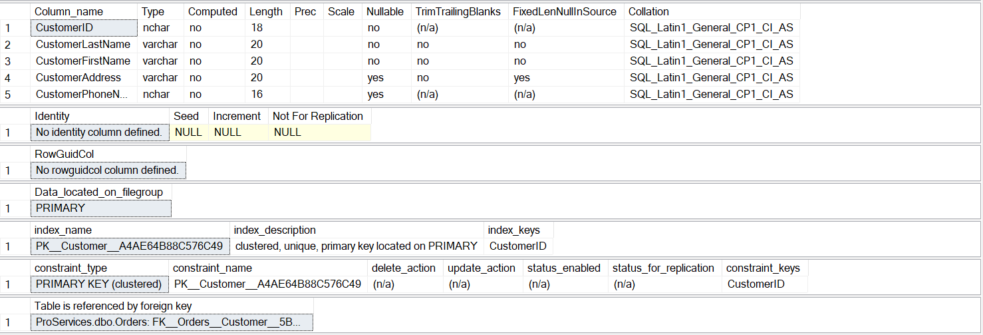

# 10-Order:

# 11-Service:

# 12-TelematicSolutions:

# 13-ITsolution:

# 14-PowerBackup:

# 15-SoftwareSolution:

# 16-MicrosotBusiness:

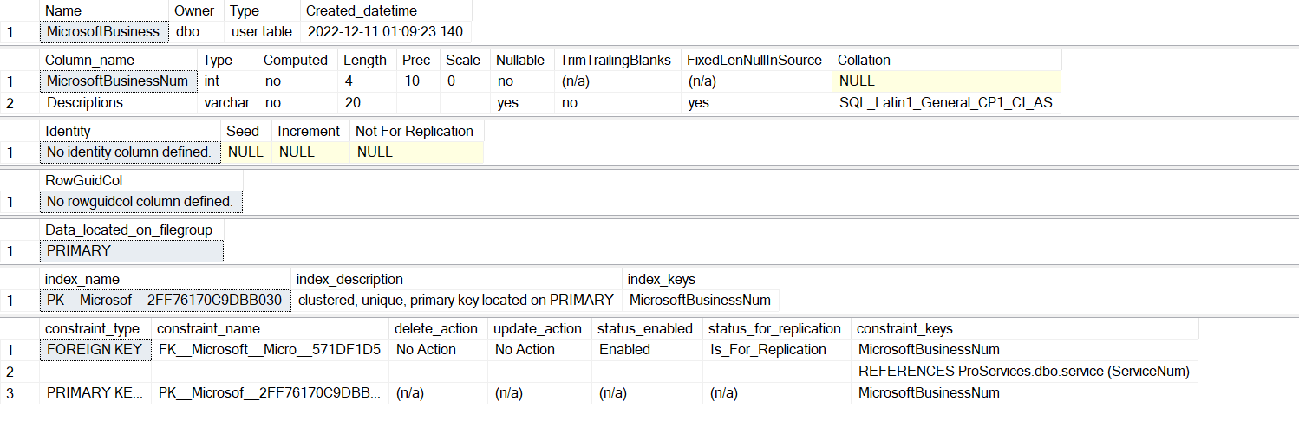

1. ***SQL Management Studio Insert into Tables:***

Insert into Employee

Values ('0001','Khoury','Jean','Beirut','76828671','2','RegularEmployee'),

('0002','Berkachi','Antoine','Byblos','71783756','1','Supervisor'),

('0003','Ramada','Hadi','Byblos','03804824','4','RegularEmployee'),

('0004','Rahal','Rozan','Beirut','78709685','5','RegularEmployee'),

('0005','Zeinab','Tiya','Tripoli','79384756','3','Manager'),

('0006','Hammoud','Haya','Beirut','03102856','2','RegularEmployee'),

('0007','Houri','Salim','Byblos','71123908','3','Supervisor'),

('0008','Itani','Adam','Beirut','81234567','2','Manager'),

('0009','Hassan','Jamil','Sayda','76987463','5','RegularEmployee'),

('0010','Daher','Kevin','Beirut','03908213','1','Manager'),

('0011','Hajjar','Matilda','Sour','76867489','2','RegularEmployee'),

('0012','Karazi','Mira','Byblos','81109876', '4','Supervisior'),

('0013','Keyrouz','Mariam','Sour','76123123','5','Manager'),

('0014','Zoor','Maya','Tripoli','03234234','2','Supervisor'),

('0015','Messi','Lionel','Beirut','81345345','4','Manager'),

('0016','Nader','Halim','Byblos','76678678','5','Supervisor'),

('0017','Sabra','Omar','Sayda','03908746','2','RegularEmployee'),

('0018','Osta','Ralph','Beirut','79109876','1','RegularEmployee'),

('0019','Ismail','Hassan','Beirut','81230196','5','RegularEmployee'),

('0020','Merouch','Lynn','Beirut','78912378','4','RegularEmployee');

Insert into Supervisor

Values ('0002','3','5000'),('0007','2','2000'),

('0012','4','4400'),('0014','3','4600');

Insert into RegularEmployee

Values ('0003','001','1700'), ('0004','001','1200'), ('0006','001','2100'),

('0009','002','2600'), ('0011','002','2200'), ('0017','003','1900'),

('0018','004','2000'), ('0019','005','2100'), ('0020','005','2300');

Insert into Manager

Values ('0005','6', '4500'), ('0008','1','3000'), ('0010','4','6000'),

('0013','2','3900'),('0015','2','4500');

Insert into Team

Values ('001','0002','6'), ('002','0007','1'), ('003','0012','4'),

('004','0014','2'), ('005','0014','5');

Insert into Department

Values ('1','IT','7'), ('02','HR','2'), ('3','Marketing','5'), ('4','Finance','3'), ('5','Accounting','3');

Insert into Task

Values ('1','1','21/12/2021'), ('2','2','9/4/2012'), ('3','3','4/2/2017'),

('4','4','1/1/2010'), ('5','5','24/7/2018');

Insert into Operation

values ('1','02'),('2','21'),('3','18'),('4','05'),('5','16'),('1','11'),('2','07'),

('3','03'),('4','17'),('5','10'),('1','04'),('2','14'),('3','15');

Insert into Customer

Values ('000000001','Nabha','Rashid','Beirut','03775631'),

('200000002','Nassif','Lara','Beirut','76701752'),

('200000003','Rizk','Romanos','Baabda','71123456'),

('000000004','Haddad','Karl','Sour','70312450'),

('000000005','Jawde','Joseph','Byblos','78423570'),

('000000006','helou','Elie','Byblos','78423570');

Insert into Orders

values ('22','000000001'), ('04','000000002'), ('19','000000003'),

('06','000000004'), ('09', '000000006');

Insert into service

Values ('01','ServicesProvider','100','MicrosoftBusiness'), ('02','GPS','200','TelematicsSolution'),

('03','SocialInformation','150','ITSolution'), ('04','ProcessControl','130','ITSolution'),

('05', 'Yahoo','80','SoftwareSolution'), ('06','Windows','70','SoftwareSolution'),

('07', 'Batteries','200','PowerBackup'), ('08', 'Sensor', '220','TelematicsSolution'),

('09','EngineGednerator','200','PowerBackupSolution'), ('10', 'Photoshop', '50','SoftwareSolution'),

('11', 'EntrepriseAgreement', '170','MicrosoftBusiness'), ('12','Geotab','300','TelematicsSolution'),

('13','Google','50','SoftwareSolution'), ('14','GIS','300','TelematicsSolution'),

('15','DataWarehouse','260','ITSolution'), ('16','DecisionSupport','240','ITSolution'),

('17','SelectPlusLiscencing','150','MicrosoftBusiness'), ('18','ERP','400','ITSolution'),

('19','FireFox','20','SoftwareSolution'), ('20','AMS','90','TelematicsSolution'),

('21','UPS','100','PowerBackupSolution'), ('22','APS','200','PowerBackupSolution'),

('23','OpenLiscenicing','150','MicrosoftBusiness');

Insert into TelematicsSolution

Values ('02','Car'),('08','Safe'),('14','Car'),('12','Computer'),('20', 'Phone');

Insert into ITSolution

Values ('03','InformatioNLack'), ('04','Inconsistancy'), ('15','Redundancy'), ('16','Undetermination'),

('18', 'WeakWorkProcess');

Insert into PowerBackup

Values ('07','6'), ('21', '15'), ('22', '20'), ('09','10');

Insert into SoftwareSolution

Values ('06','Practical'), ('05','WideSource'), ('10', 'ModifyImages'), ('13','WideSource'),

('19','PrivateBrowsing');

Insert into MicrosoftBusiness

Values ('01', 'SeveralServices'), ('23', 'LifeTimeLiscence'),('17','LargeOrganizations'),

('11', ' OnlineServices');

1. ***SQL Management Studio Populated Tables:***

# 1-Employee:

# 2-Supervisor:

# 3-Regular Employee:

# 4-Manager:

# 5-Team:

# 6-Department:

# 7-Task:

# 8-Operation:

# 9-Customer:

# 10-Order:

# 11-Service:

# 12-TelematicSolutions:

# 13-ITsolution:

# 14-PowerBackup:

# 15-SoftwareSolution:

# 16-MicrosotBusiness:

1. ***SQL Management Studio Queries***

# 1-For Description:

EXEC sp_help 'Employee'

EXEC sp_help 'Supervisor'

EXEC sp_help 'RegularEmployee'

EXEC sp_help 'dbo.Manager'

EXEC sp_help 'Team'

EXEC sp_help 'Department'

EXEC sp_help 'Task'

EXEC sp_help 'Operation'

EXEC sp_help 'Service'

EXEC sp_help 'TelematicsSolution'

EXEC sp_help 'ITSolution'

EXEC sp_help 'PowerBackup'

EXEC sp_help 'SoftwareSolution'

EXEC sp_help 'MicrosoftBusiness'

# 2-Query to show tables data:

select *

from Employee

select*

from Supervisor

select*

from RegularEmployee

select*

from Manager

select*

from Team

select *

from Department

select*

from Task

select *

from Operation

select *

from Customer

select *

from orders

select*

from Service

select*

from TelematicsSolution

select *

from ITSolution

select*

from PowerBackup

select*

from SoftwareSolution

select*

from MicrosoftBusiness

# 3-Custom Queries:

--retrieve first and last name of every employee:

select EmployeeFirstName, EmployeeLastName

from Employee

--retrieve the name of accounting department

select EmployeeFirstName, EmployeeLastName

from Employee

where EMployeeType = 'Manager' and department_Number = '5'

--Group each service type and count the number of services offered in them

select ServiceType, count(*)

from service

group by serviceType

--Average manager salary

select avg(salary)

from Manager



--Most and least expensive service

select max(ServiceCost), min(serviceCost)

from service

---Retieve names and phone numbers of customers that live in Beirut (for marketing purposes)

select CustomerFirstName, CustomerAddress, CustomerPhoneNum

from customer

where CustomerAddress = 'Beirut'

---Retieve customers names and service they purshased

select CustomerFirstName, CustomerLastName, ServiceName

from customer, orders, service

where Customer_ID = CustomerID and ServiceNum = Service_Num

1. ***Progress Report:***

Meetings: Total of 9

October 10 3 pm 🡪First meeting was related to what questions will be asked with the manager

October 12 3:30 pm🡪 This meeting was the interview with the manager where we asked the questions that we agreed on in the previous meeting

October 17 1 pm 🡪 Made our scenario and business rules

October 12 at 1 pm🡪 created our relational schema and the ER Diagram

November 19 2:30🡪 Mapping

November 24 3:30🡪 Reviewing and checking up on all we did up to this point and then proceeding to normalize the schema

December 1 at 10 🡪 Beginning of the SQL (10 to 15 on table of contents)

December 10 at 4:20 pm 🡪 finalizing our SQL and fixing the errors on my SQL server

December 11 at 5 pm 🡪 Going over the project as a whole and practicing out presentation

The group worked in perfect harmony as everyone met the deadlines that were provided, communication was on point and whenever there was a problem, we all solved it together.

Everyone contributed to the group fairly and no conflicts occurred😊